Set:

Grilled chicken chop - RM 19.90

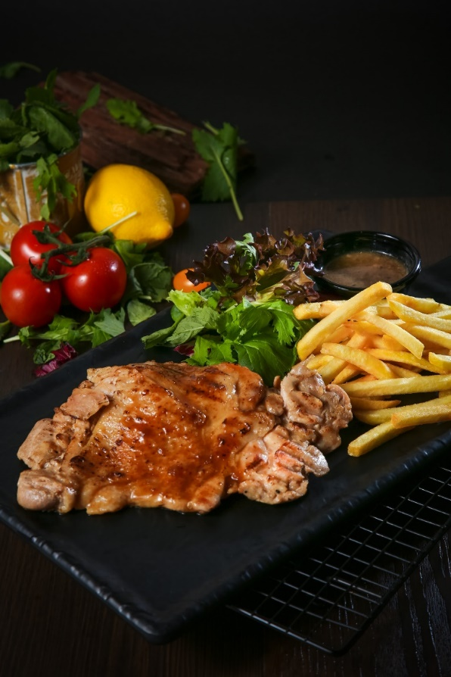

Grilled lamp chop – RM25.90

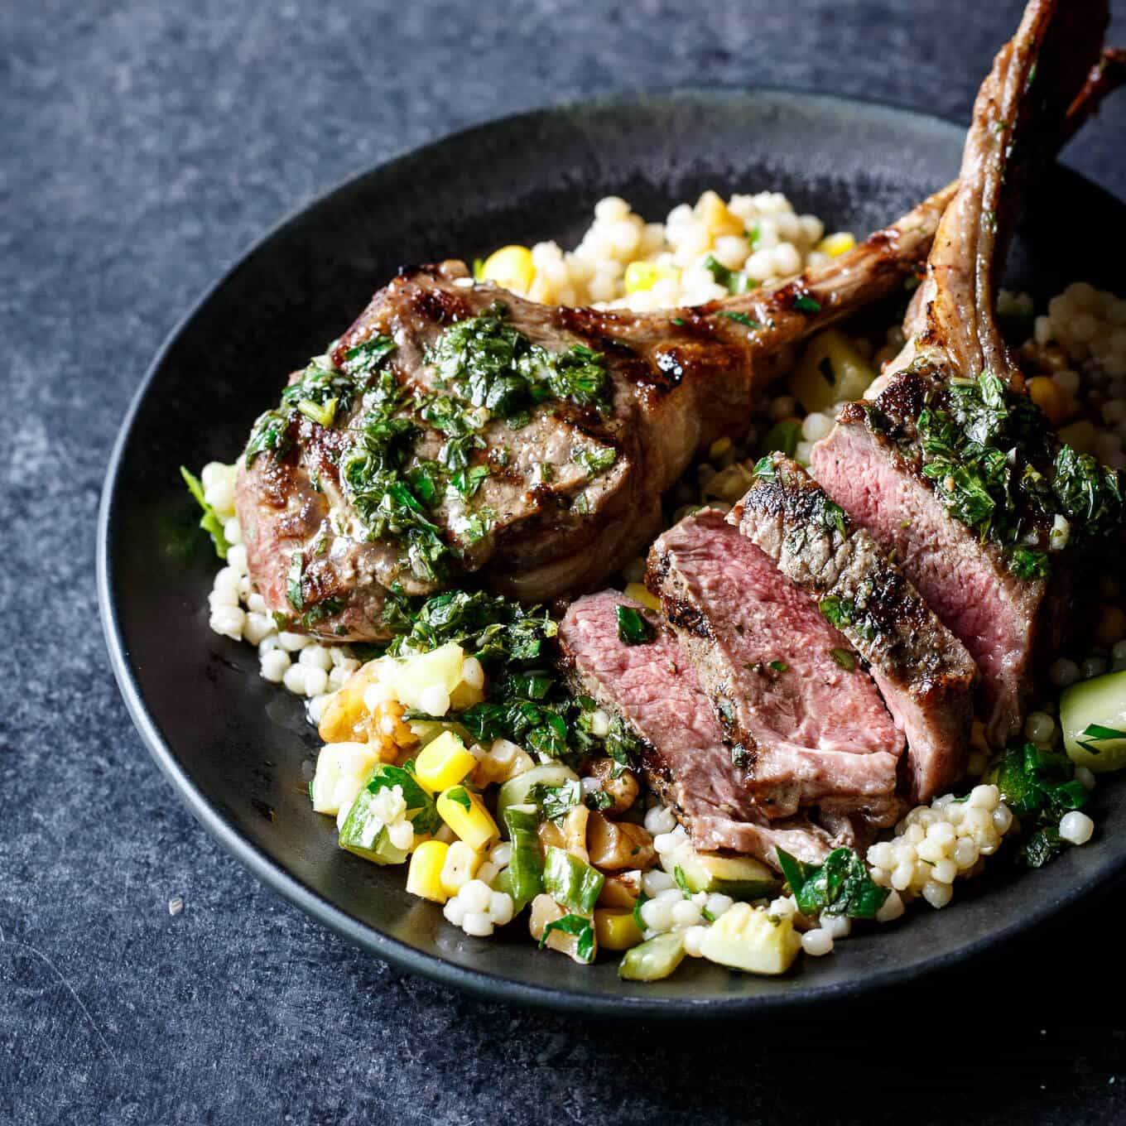

Grilled Fish Fillet – RM 19.90

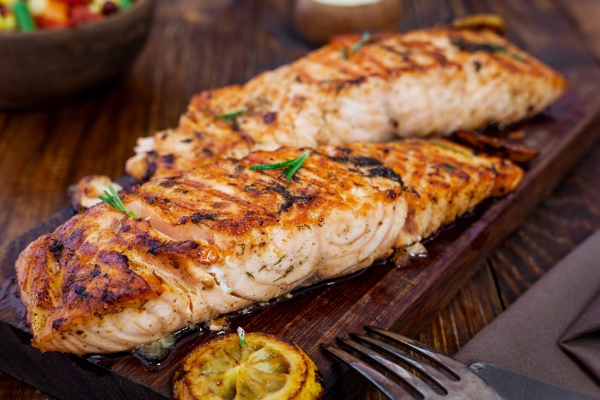

Grilled Beef chop -RM 26.90

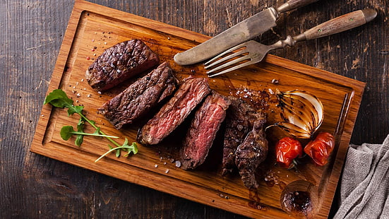

Breakfast:

Sunshine Sausage Delight (egg,sausage, baked bean and salad) – RM 13.90

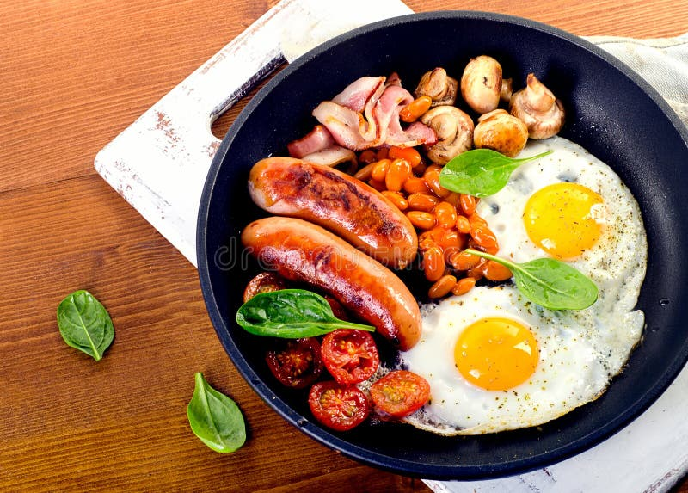

Majestic Morning Meal (Upgraded Sunshine, with ham, bread, mashed potatoes, butter and etc) – RM 20.90

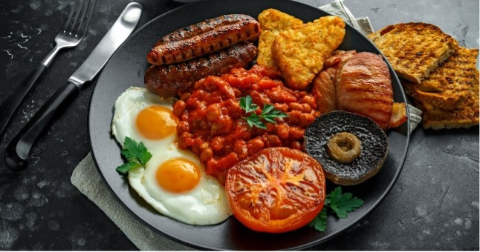

Baguette – RM 8.00

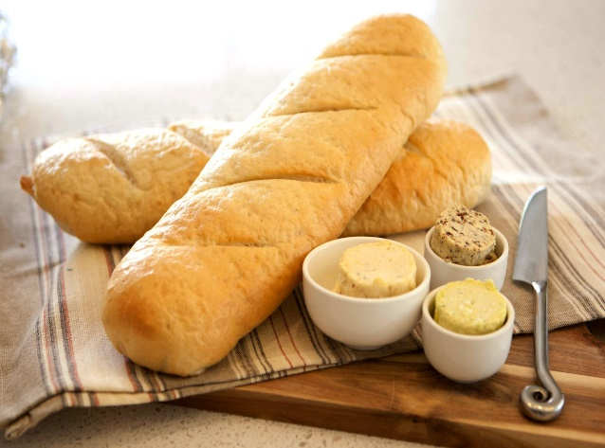

Brioche – RM 6

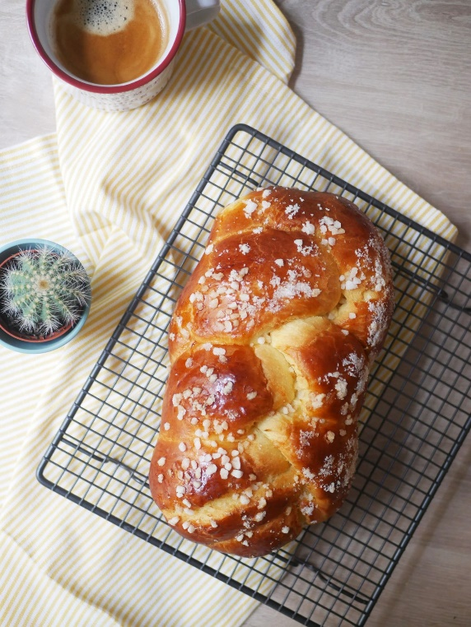

Noodle:

spaghetti carbonara – RM 18.90

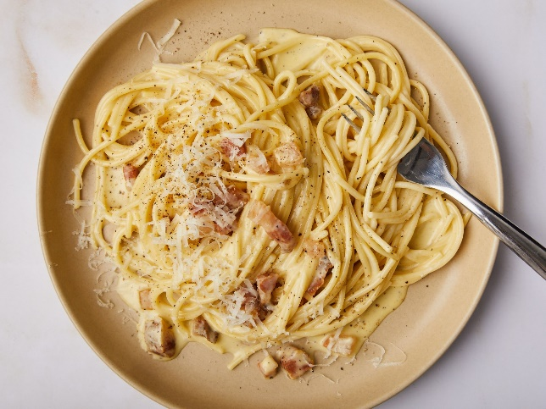

spaghetti aglio olio – RM 18.90

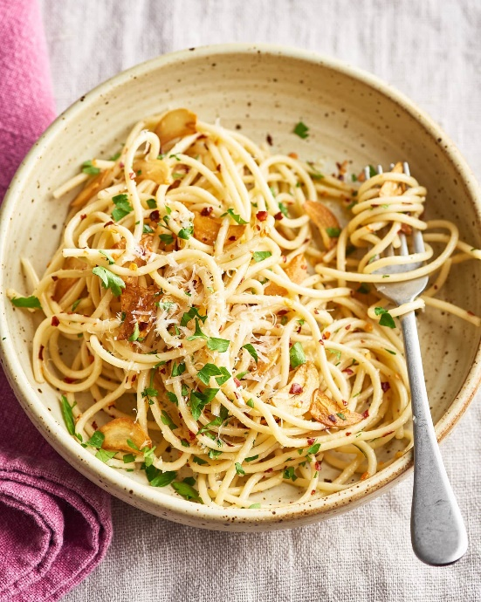

spaghetti Pesto – RM 20.90

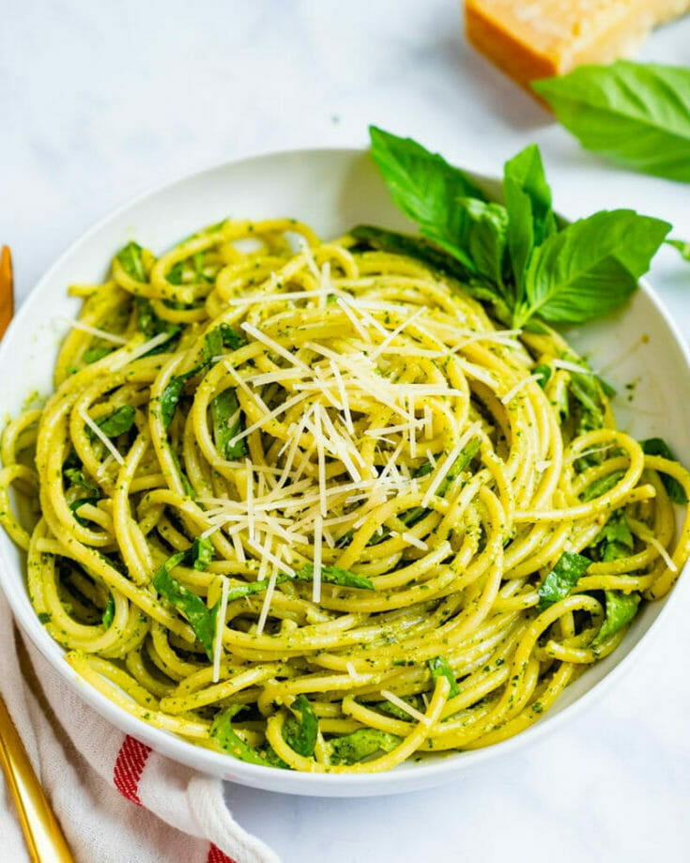

spaghetti Bolognese – RM 18.90

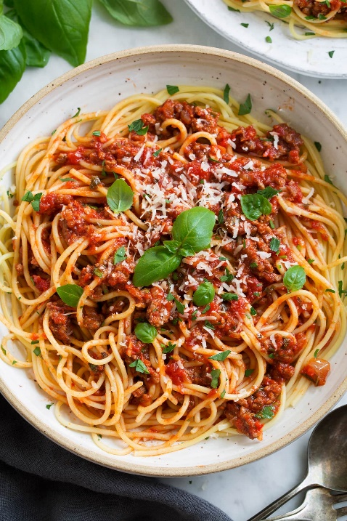

Rice:

Yang Zhou Fried Rice – RM 14.00

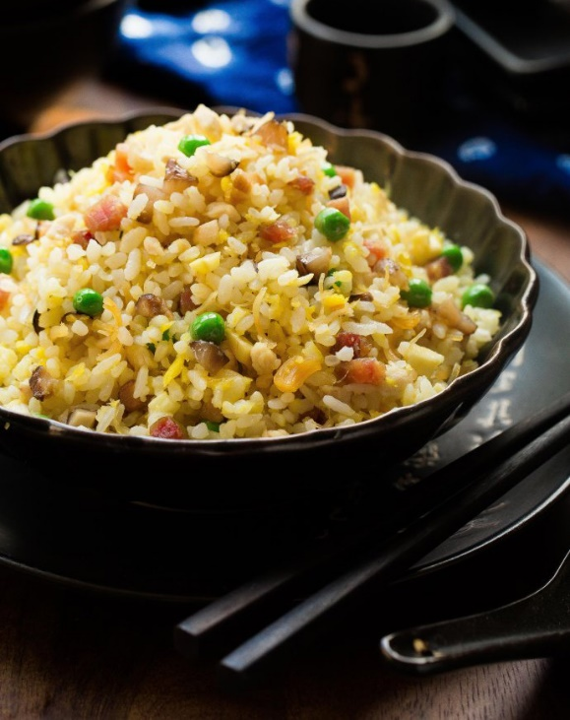

USA Fried Rice (Udang, Sotong, Ayam) – RM 26.90

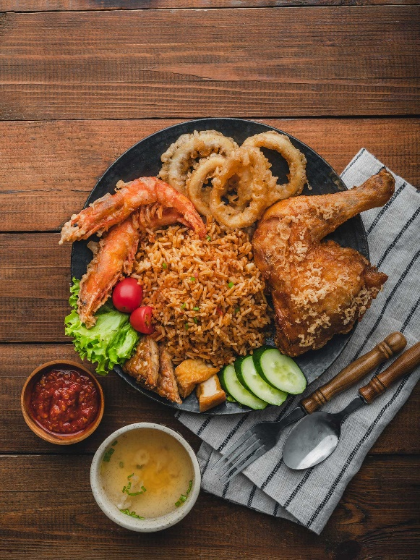

Mango sticky rice – RM 13.90

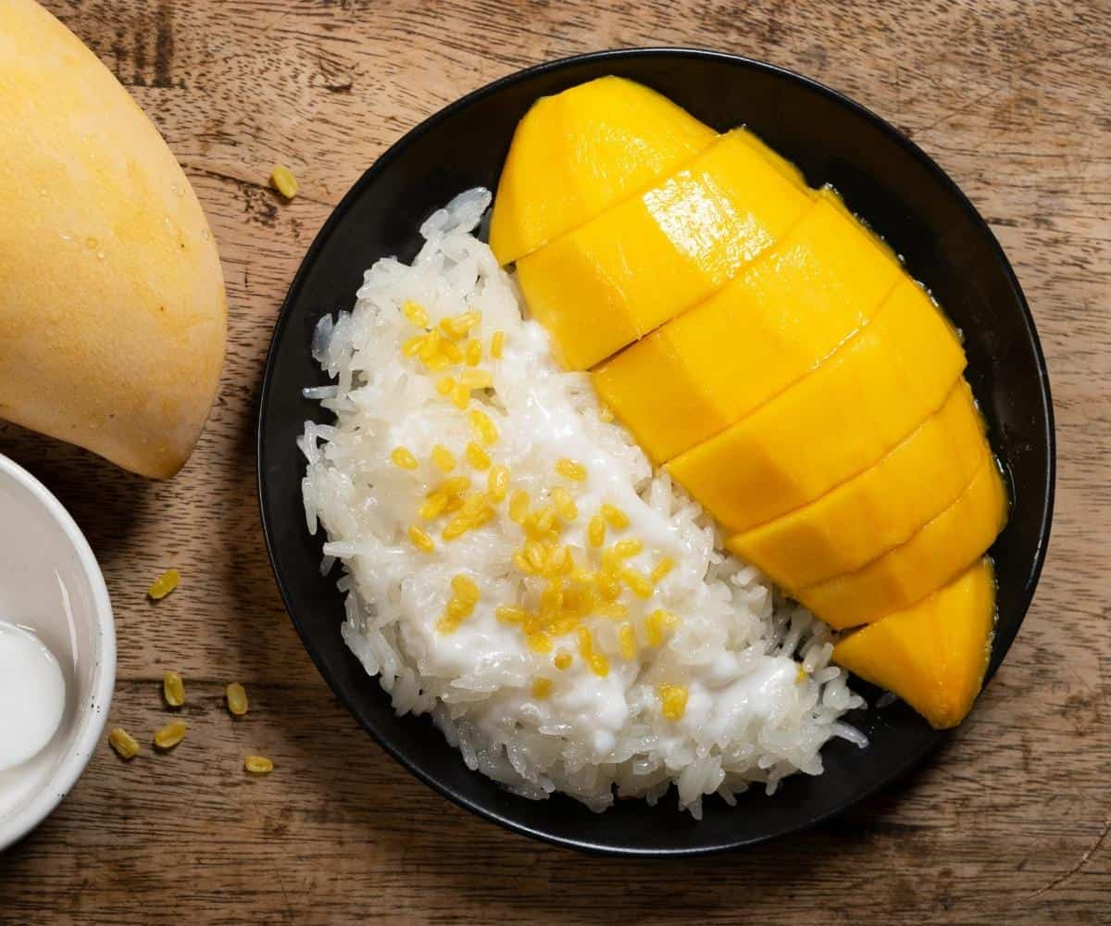

Onigiri – RM 5.00

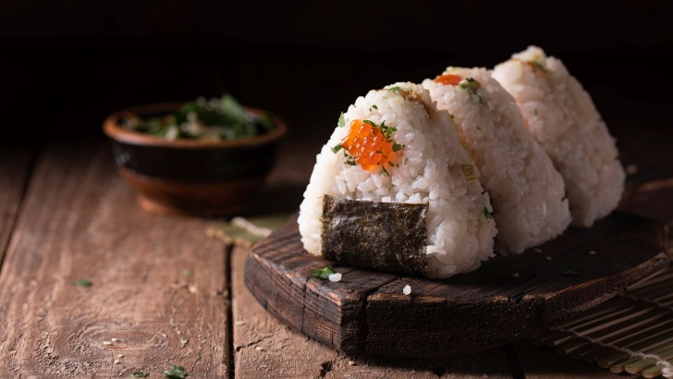

Dessert:

Steamed Bread – RM 2.50

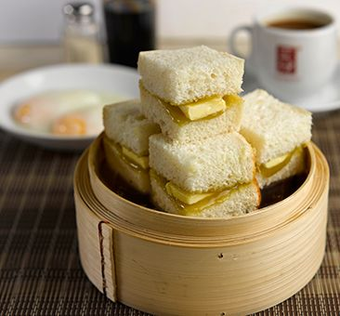

Toasted bread – RM 2.50

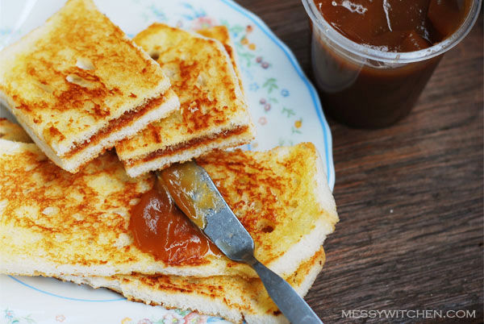

Sandwich – RM 5.00

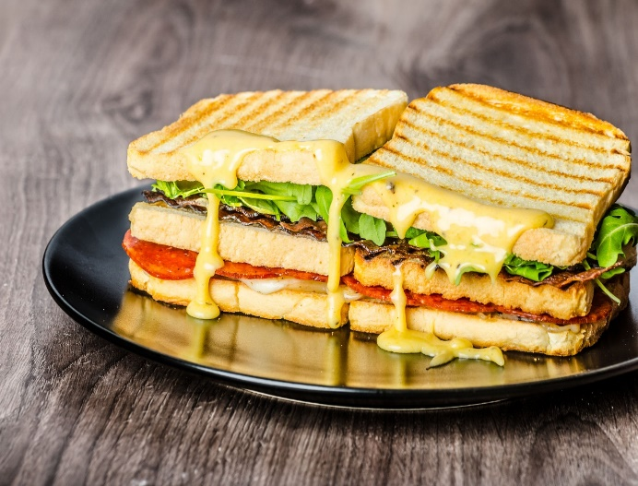

Pancake – RM 15.90

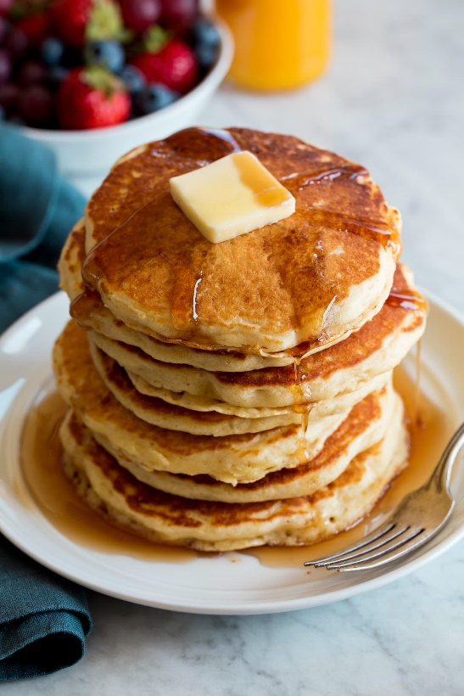

Lava Cake – RM 12.00

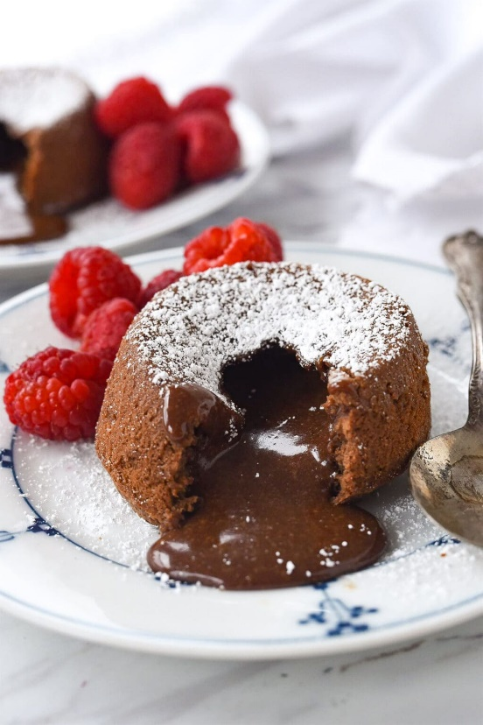

Cheesecake – RM 15.00

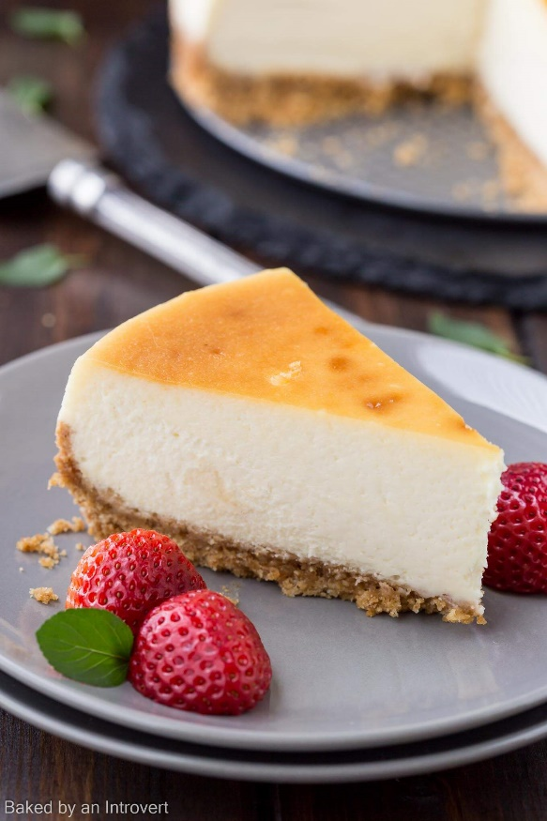

Drink:

Cold Brew – Rm 8.00



Ice Americano – RM 8.00

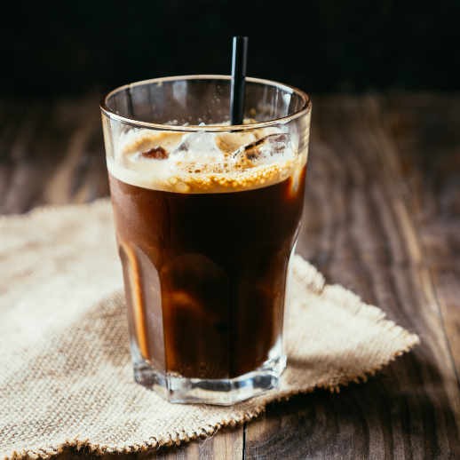

Espresso – RM 10.00



Latte – RM 8.00



Cappuccino – 9.00



Matcha – 9.00



100plus – RM 4.00

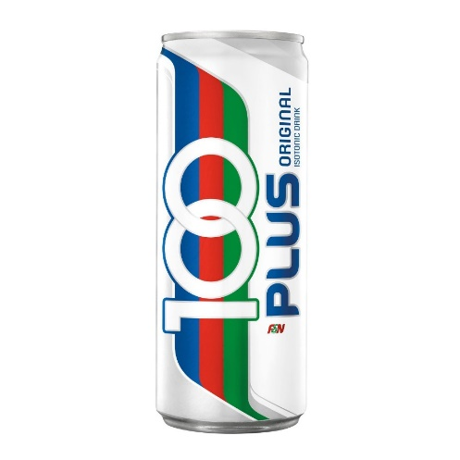

Sprite – RM 4.00

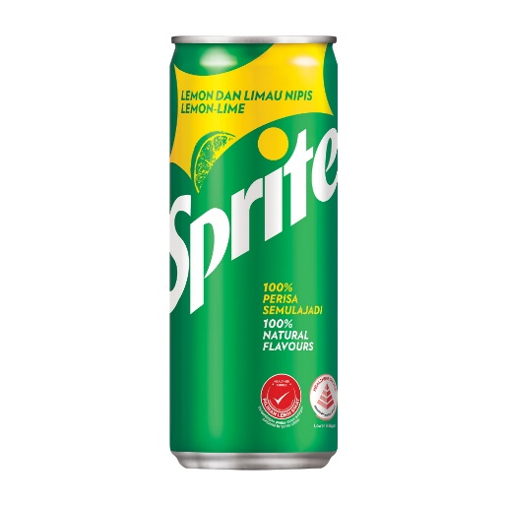

Coca-Cola – RM 4.00



A&W – RM 4.00

